**BANKING SYSTEM**

**I. ABSTRACT**

The proposed topic is a banking system that maintains client’s bank accounts and providing basic banking services such as deposit, withdraw, and change PIN. The group tried to recreate a real-life banking management system by providing a Python application which consist of two main parts: The administrative module and the ATM module. The administrative module is used and accessed by the System Administrators or Bank Tellers. It has two functionalities: To open and close accounts. In opening accounts, the new account will be added to the database system. In closing accounts, an existing account will be deleted in the database. On the other hand, the ATM module side can be used by the client in order to do deposit, withdraw, balance inquiry, or change pin transaction. First, the user must be authenticated by putting his/her card number (ATM card insertion in real-life ATM) together with the PIN number. All except balance inquiry will update the database after execution. In summary, the administrative module has open and close account functionalities while ATM module has deposit, withdraw, change pin and check balance transaction.

**II. OBJECTIVE**

* To create a project that uses Python programming together with a database system.
* To be able to implement a banking management system by providing an application that can offer basic bank transactions.

**III. PROJECT PARTS**

* GUI (Qt Designer)
* Database System (SQLite)
* Main Program (Pycharm)
* Create Account
* Close Account
* ATM Transactions (Session, Deposit, Withdrawal, Balance Inquiry, Change PIN)

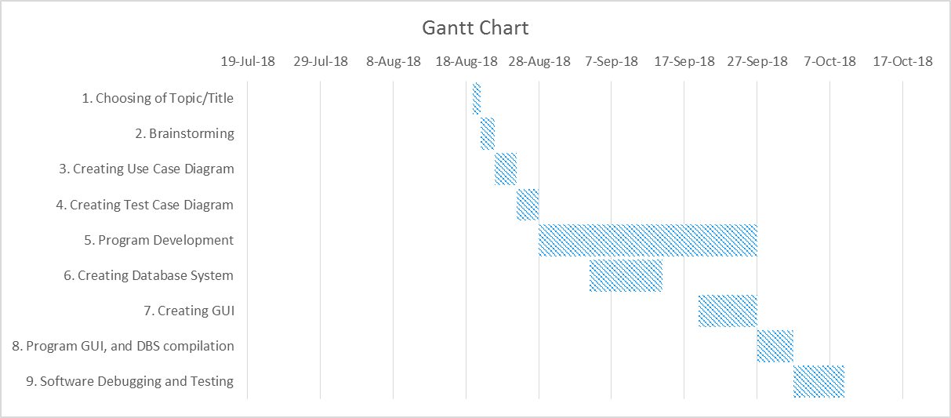**IV. GANTT CHART**

**V. USE CASE DIAGRAM**

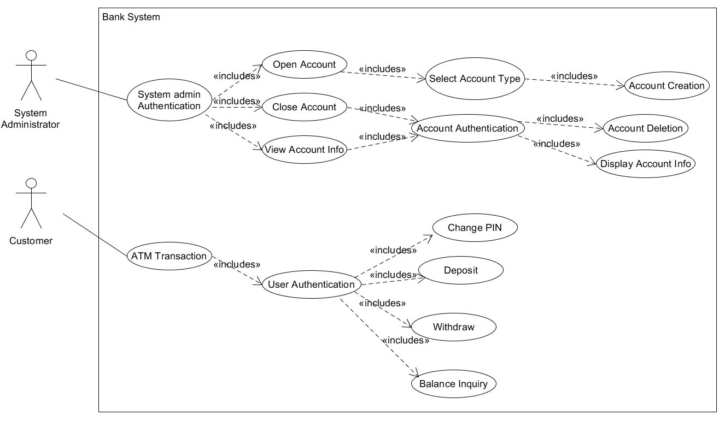

**VI. TEST CASE DIAGRAM**

|  |  |  |  |  |  |
| --- | --- | --- | --- | --- | --- |
| TC#1 – Creating an Account | | | | | |
| TC_ID# | Test Objective | Precondition | Steps | Test Data | Expected Result |
| TC_A1 | Authenticate System Administrator | System is on and displaying a login page | Input system admin username and password |  | System displays system administrator homepage |
| TC_A2 | System rejects system admin username/password | System is on and displaying a login page | Input invalid system admin username and password |  | System displays an error screen and is ready to start a new session |
| TC_A3 | System allows system admin to choose Create account option | The user must be logged-in as System Administrator | Choose Create account option |  | System displays Create account option session |
| TC_A4 | Create non-existing account on desired account type | Create account session is displayed | 1. Type-in user details  2. Type-in account details on non-existing account type |  | System displays User account successfully created and goes back to homepage |
| TC_A5 | Create existing account on desired account type | Create account session is displayed | 1. Type-in user details  2. Type-in account details on existing account type |  | System prompts User account already existed on desired account type |
| TC_A6 | Update Database | The user must have created a valid account | Update database by adding the newly created user on Account files |  | System displays successfully updated the database |

|  |  |  |  |  |  |
| --- | --- | --- | --- | --- | --- |
| TC#2 – Closing an Account | | | | | |
| TC_ID# | Test Objective | Precondition | Steps | Test Data | Expected Result |
| TC_B1 | Authenticate System Administrator | System is on and displaying a login page | Input system admin username and password |  | System displays system administrator homepage |
| TC_B2 | System rejects system admin username/password | System is on and displaying a login page | Input invalid system admin username and password |  | System displays an error screen and is ready to start a new session |
| TC_B3 | System allows system admin to choose Close account option | The user must be logged-in as System Administrator | Choose Close account option |  | System displays Close account option session |
| TC_B3 | Close existing account | Close account session is displayed | Enter valid savings/checking account# and PIN |  | System displays User account successfully closed and goes back to homepage |
| TC_B4 | Close non-existing account | Close account session is displayed | Enter invalid savings/checking account# and PIN |  | System displays an error screen and is prompt to enter again |

|  |  |  |  |  |  |
| --- | --- | --- | --- | --- | --- |
| TC#3 – ATM Transaction (Session) | | | | | |
| TC_ID# | Test Objective | Precondition | Steps | Test Data | Expected Result |
| TC_C1 | System authenticates the user | System is on and not servicing a customer | Insert card (user card#) and PIN |  | System displays a menu of transaction types |
| TC_C2 | System rejects invalid user card (card#) | System is on and not servicing a customer | Insert invalid card (user card#) and PIN |  | System displays an error screen and is ready to start a new session |
| TC_C3 | System asks user to re-enter PIN | Request to re-enter PIN is being displayed | Enter incorrect PIN |  | Customer is asked to re-enter PIN |
| TC_C4 | Customer exceeds max number of re-entries of PIN (3 entries) and system aborts transaction | Request to re-enter PIN is being displayed | Enter 3rd incorrect PIN |  | System displays an error screen and session is terminated |
| TC_C5 | System allows customer to perform a transaction | Menu of transaction types is being displayed | Perform a transaction |  | System asks whether customer wants another transaction |
| TC_C6 | System allows multiple transactions in one session | System is asking whether customer wants another transaction | Choose yes/no |  | System displays a menu of transaction types |
| TC_C7 | Session ends when customer chooses not to do another transaction | System is asking whether customer wants another transaction | Choose yes/no |  | System terminates and is ready to start a new session |

|  |  |  |  |  |  |
| --- | --- | --- | --- | --- | --- |
| TC#4 – ATM Transaction (Deposit) | | | | | |
| TC_ID# | Test Objective | Precondition | Steps | Test Data | Expected Result |
| TC_D1 | System allows customer to perform a Deposit transaction | Menu of transaction types is being displayed | Choose Deposit transaction |  | System displays the Deposit transaction session |
| TC_D2 | System allows customer to choose an account to deposit to | Menu of account types is being displayed | Choose Checking or Savings account |  | System displays a request for the customer to type a peso amount |
| TC_D3 | System denies user account type option | Menu of account types is being displayed | Choose invalid account type |  | System prompts the customer doesn’t have the desired account type |
| TC_D4 | System allows customer to enter a peso amount to deposit | System is displaying a request for the customer to type a peso amount | Enter a legitimate peso amount |  | System prints receipt showing amount and updated balance and asks whether customer wants another transaction |

|  |  |  |  |  |  |
| --- | --- | --- | --- | --- | --- |
| TC#5 – ATM Transaction (Withdrawal) | | | | | |
| TC_ID# | Test Objective | Precondition | Steps | Test Data | Expected Result |
| TC_E1 | System allows customer to perform a Withdrawal transaction | Menu of transaction types is being displayed | Choose Withdrawal transaction |  | System displays the Withdrawal transaction session |
| TC_E2 | System allows customer to choose an account to withdraw from | Menu of account types is being displayed | Choose Checking or Savings account |  | System displays a request for the customer to type a peso amount |
| TC_E3 | System denies user account type option | Menu of account types is being displayed | Choose invalid account type |  | System prompts the customer doesn’t have the desired account type |
| TC_E4 | System verifies that customer's balance is sufficient to fulfill the request | System is displaying a request for the customer to type a peso amount | Choose an amount that is not greater than the account balance |  | System prints receipt showing amount and updated balance and asks whether customer wants another transaction |
| TC_E5 | System verifies that customer's balance is insufficient to fulfill the request | System is displaying a request for the customer to type a peso amount | Choose an amount that is greater than the account balance |  | System displays an appropriate message and asks customer to choose a different amount |
| TC_E6 | System verifies that customer's withdrawal amount is greater than per transaction limit amount (10000Php) | System is displaying a request for the customer to type a peso amount | Choose an amount that is greater than per transaction limit amount |  | System displays an appropriate message and asks customer to choose a different amount |

|  |  |  |  |  |  |
| --- | --- | --- | --- | --- | --- |
| TC#6 – ATM Transaction (Balance Inquiry) | | | | | |
| TC_ID# | Test Objective | Precondition | Steps | Test Data | Expected Result |
| TC_F1 | System allows customer to perform a Balance Inquiry transaction | Menu of transaction types is being displayed | Choose Balance Inquiry transaction |  | System displays the Balance Inquiry session |
| TC_F2 | System allows Customer to choose an account to inquire about | Menu of account types is being displayed | Choose Checking or Savings account |  | System prints receipt showing balance and asks whether customer wants another transaction |
| TC_F3 | System denies user account type option | Menu of account types is being displayed | Choose invalid account type |  | System prompts the customer doesn’t have the desired account type |

|  |  |  |  |  |  |
| --- | --- | --- | --- | --- | --- |
| TC#7 – ATM Transaction (Change PIN) | | | | | |
| TC_ID# | Test Objective | Precondition | Steps | Test Data | Expected Result |
| TC_G1 | System allows customer to perform Change PIN | Menu of transaction types is being displayed | Choose Change PIN |  | System displays the Change PIN session |
| TC_G2 | System verifies that customer's new PIN is valid | System is displaying a request for the customer to enter new PIN | Enter new PIN |  | System prompts the customer that current PIN is changed and asks whether customer wants another transaction |
| TC_G3 | System verifies that customer's new PIN is invalid | System is displaying a request for the customer to enter new PIN | Enter invalid or same PIN |  | System displays an appropriate message and asks customer to choose a different PIN |

**VII. MOCKUPS DESIGNS**



